ABOUT RIPAT
RIPAT (Rural Initiatives for Participatory Agricultural Transformation) is one such approach, developed among small scale farmers in Northern Tanzania by a local NGO, RECODA under the partnership/sponsorship of the Rockwool Foundation. Projects under RIPAT are economic development interventions that aim at closing the agricultural technology gap as a means of improving livelihoods and self-support among impoverished small scale farmers. The RIPAT intervention was intended to find sustainable, low-cost solutions to the challenges faced by small-scale farmers by providing proper tools, techniques and information in a participatory help-to-self-help approach; which deliberately takes its starting point in the fact that one-size does not fit all.
RIPAT is a pragmatic mix of traditional Training and Visit (T&V) and participatory extension approaches, such as Farmer Field Schools. It mobilize farmers to have vision of development and join in groups where varied ‘basket of technology options’ are introduced, leaving each individual farmer with a genuine possibility of choice as to which technologies to adopt, when and to what extent, depending on their needs and resources.
Farmers’ Choice is a book which presents the research results (FACTS – what came out of RIPAT and ‘how and why did it happen) while the RIPAT Manual represents ACT (How to make it happen’ or ‘how to ACT in order to get the same results; i.e. these are two books from the RIPAT interventions and from the research – which complement one another.
RIPAT manual is free downloadable from www.ripat.or.tz

Why RIPAT (Why RIPAT has been developed )?
RIPAT was developed to respond to two questions – or two challenges:
- Why so many agricultural development projects have generated so little impact among rural farmers.
- Why so many improved agricultural technologies are developed, but not adopted by small scale farmers.

What is RIPAT?
RIPAT is an APPROACH to agricultural development through motivation, grouping, and new knowledge; is a kind of an extension approach – a generic model – on how to design agricultural development projects for small holders; and is about how to reach farmers with new knowledge in a way they find relevant. A RIPAT project can include various types of technologies (basket of options) – depending on the local setting. So RIPAT is like a truck – or a camel – that can carry various types of new knowledge/ technologies interventions.
The goal has been to reduce poverty (improve income), environmental conservation, and food and nutrition security.
RIPAT uses the best from the traditional, ‘top down’ extension method called ‘Training and Visiting (T&V), and the ‘bottom up’ extension method called ‘Farmers Field School (FFS). It should be noted that RIPAT is NOT about specific agricultural technologies or methods.

RIPAT Manual - The Manual is for whom?
The RIPAT Manual explains step-by-step how to organize and implement a robust group-based agricultural development project. The manual is meant for those who are interested in improving the food security and incomes of small-scale farmers: primarily practitioners, but also teachers, researchers and decision makers. The manual is especially relevant for staff of NGOs and development organizations at programming and field levels, and for local government officials involved in agricultural extension and rural development.

Where RIPAT works best
In principle the RIPAT approach should be applicable in most agricultural based communities.RIPAT work best where farmers live relatively close to one another (should not exceed 5 km),with relatively good conditions for agriculture and where the population is settled as the participating farmers must be permanentlyresident and have crop and livestock production as a part of their livelihood.
The entry point is not so much about technologies but merely about mobilizing and sensitizing communities and individuals to take charge for their own development and to promote utilization of locally available resources for livelihoods improvement. RIPAT is designed for the active poor small scale farmers with the ability to move from the poverty level into the mid level of the wealth ranking.

Why RIPAT – By Professor Mattee
Unlike other extension approaches used in Tanzania after been adapted from other countries; RIPAT approach has been developed based on the environment of our country. Among the best way of initiating positive development and poverty alleviation among rural farmers achieved through community sensitization, mobilization and capacity building to utilize locally available resources and opportunities for livelihoods improvements leading to self reliance and improved living standards make RIPAT to be a peculiar approach.

Late Professor Amon Z. Mattee, Department of Agricultural Education and Extension, Sokoine University of Agriculture, Morogoro, Tanzania showed why RIPAT in his endorsement that; ‘This is an excellent, easy-to-follow, step-by-step guide on how organizations working with small-scale farmers should approach their task. This is a “must have” resource book for all extension and rural development practitioners, be they from government or from the NGO sector. For a long time in Tanzania there has not been any such a manual to guide extension work and this will certainly fill the gap.’

What is the RIPAT’s impact and reasons behind?
The scientific documentation from the completed RIPAT projects verifies that the approach provides a key for unlocking the so far largely untapped agricultural potential among smallholder farmers; which shows:
- Increased levels of food security among participating farmers.
- Improved levels of nutrition among adults and children
- Sustained adoption of most of the agricultural technologies promoted
- Diffusion of the most popular technologies to non-participant farmers in the local communities.

Some reasons behind the good results
- Free choice from a ‘basket of options’
- Each farmer to belong to a strong farmers’ group contributes to an increased sense of empowerment among the farmers – especially among female farmers. It also increases the farmers’ bargaining power with more knowledge about and a say in agricultural matters.
- The vast majority of established RIPAT groups continue to work together after project completion.
- The organizational management structure around RIPAT i.e. a management structure which entails both joint experiential learning in groups, a pragmatic combination of traditional and participatory extension approaches, and a strong focus on integrating both local needs, resources and conditions of small-scale farmers as well as involving local governmental authorities into the intervention design.
Important issues/features to observe under RIPAT:
1. A vision of a better future – see the end/destination (super household) from the beginning.
- Creation of a vision of a better future through the careful sensitization of communities to the potential for change and the mobilization of farmers to take charge of their own development is very crucial under RIPAT approach. Development is a thinking job. Before embarking on community economic development project, anyone who wants to join the project will be interested to know from the beginning how his/her household will be after time ‘T’ (1 – 3 or 5 years).Under their circumstances, what will the project do differently so that they can come out from poverty and food insecurity? How can they comprehend the image – figure out on how the life will be or how their household will be (look-like, the imagination) in future. It is important to draw an illustration/image of the system components showing their spatial arrangements, interactions and values(picture of super household model suitable for agro-ecological/farming systems Y; which also depends on the selected basket of options).
RIPAT helps farmers to set goal/vision and remained focused knowing that development is a process which should be achieved; there is no quick fix and cannot be provided in a silver plate by quoting the wise saying of the first president of Tanzania MwalimuNyerere that; ‘people cannot be developed – but they can only develop themselves’.
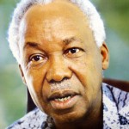MwalimuNyerere
2. Situation analysis and project design
This is a participatory field survey (PRA) which is conducted to identify challenges, potentials and opportunities and to suggest relevant interventions and undertake a stakeholders’ analysis. In this stage of project designing various stakeholders especially the beneficiaries and local authorities are encouraged to participate in order to lay foundation for project sustainability. The output under this activity is project proposal with a well established basket of options and logical framework (objectives, performing indicators, outputs, activities and some assumptions).
3. Community sensitization, mobilization and group formation
A. Community mobilization and sensitization
Communities are encouraged to come together and are supported to analyze their own situations and take steps (work together)to the goal and objectives of the RIPAT project. Different stakeholders including district officials and Ward Development Committee (WDC) members are involved from the situation analysis and throughout to group formation. When the implementation kicks off village governments are informed to mobilize the community (village meeting) where RIPAT facilitators and WDC members are responsible for the sensitization, awareness creation and developing the right attitude towards the project. The project goal and specific objectives are clearly shared with the leaders at the various levels of operation and the beneficiaries. The method of implementation and the roles and responsibilities of each stakeholder are also shared together with the expected outputs – where the image of vision of super household model is displayed and described
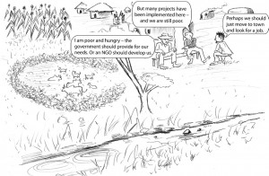
B. Group formation and development
Scattered small scale farmers are mobilized into groups with good leadership to enable the transfer of appropriate agricultural technologies through participatory demonstrations and reflective learning techniques. Criteria for group formation are explained during the village meeting followed by the selection of group members; where two groups comprising of 35 members are formed per village i.e. approximately 70 households in each village. The mode of implementation is explained to the group members and each of them commits themselves to continue with the groups or the unwilling members drop out at this early stage and are replaced. Mobilization, sensitization and group development is a continuous process throughout the project lifespan – whereby training on group development (dynamics and cohesion are undertaken). Coming together in groups not only for training purposes but for also group dynamics leading to interactions and challenging one-another which influence change of attitudes/behaviour and strength of togetherness which in later stages the groups may act as a local institution. Further explanation about group formation and development; refer RIPAT Manual page32 including learning by doing.
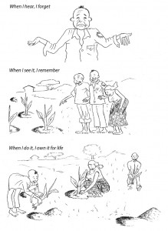
4. Help to self-help, HSH’ philosophy to avoid donor dependency
This is about avoiding donor dependency and ensuring that farmers take full charge of their own development at individual and community level. The approach insists on self-reliance as a prime foundation for freedom and development (poverty reduction and food security) while on another hand criticizing dependence syndrome which kills creativity and hardworking culture.
Under RIPAT, there is always a ‘price tag for development – nothing is for free’; every direct recipient of the project support should be responsible with supporting three other community members in terms of knowledge and planting materials while in animals they have to abide on solidarity chain (Heifer approach). In some cases where hybrid seeds are used and cannot be recycled, payback system is used i.e. farmers participating in the project are given conditions on how to recover the cost of the seeds. Under VSLA, there are community support funds which saving groups allocates for community support.
Under sister group system and recruitment of Super farmers, groups support the formation of new groups and supply them with planting materials and knowledge (Sister Group’s concept is attached).
5. Group demonstration (FFS) plot for joint experiential learning
Group plot (Farmers field School – FFS) of around one acre is an entry point of all the technologies which is mainly meant for four purposes i.e.
  - learning by doing (hands on practices
  - ii) Persuasion – that it works
  - iii) source of planting materials and
  - iv) source of income to the group and at the same time proof of good economic returns.
Crops are planted in plots based on soil suitability and arranged based of their life cycle i.e. annual – cassava, sweet potatoes, sunflower, conservation agriculture of maize intercropped with legumes, or perennial – improved banana varieties. The trials are set in a manner which can allow experimental learning / comparisons of the common practices and the introduced technologies i.e. crops under different managements.

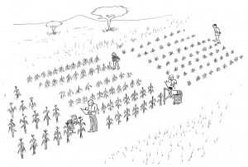
The use of systematic trials is extremely informative and good for learning because the trials are conducted with care so that the field is a good school. When farmers see the benefit from a technology, then they adopt the method, and others in the community will follow suit. All innovations are demonstrated at the FFS plots, managed by farmers in collaboration with government extension staff and facilitated by RECODA (implementing organization) staff. The methods and technologies demonstrated allow farmers to discover, reflect upon, and adjust the methods to local conditions (one size does not fit all), in order to minimize the risk of failure. Ideally, the group training enables farmers to acquire the competencies necessary to continue with small-scale experimentation on their own farms.
6. Formalized cooperation with local government authorities
RIPAT projects are being implemented in harmony with the overall government policy of poverty alleviation and food security. Under RIPAT, the ownership and continuation of community projects is very crucial and in order to ensure these the government authorities in the area of project implementation partner with RECODA throughout the project implementation period. Partnership with the government also aims at ensuring the spread of the interventions to other communities through the government extension system. District Project Coordinator (DPC) is selected to represent the project at district level but also to use authorities in enforcing bylaws and enhancing government participation especially extension officers at ward and village level. Advocacy and creation of awareness are done to the local government to further spread the RIPAT activities via the government agricultural Extension Officers.
See RIPAT Manual for an example of an MoU
7. Basket of options
Through the RIPAT project, farmers are offered a range of improved farming methods and technologies (basket of options) that are viable in their area. The basket of options gives farmers’ choice regarding agricultural technologies and working in groups gives them a voice on how they want to organize themselves and work together. ‘Basket of Options’ on various technologies rooted from situation analysis are set to improve livelihoods and resilience of Small scale farmers from different agro-ecological zones and farming systems; whereby by food security and nutrition, poverty reduction and environmental conservation are given upper hand. Under RIPAT – ‘one size does not fit all’, hence the interventions (technologies) offered are selected and tailor-made according to geographic context and woven using participatory bottom-up and top-down approaches ensures diversification, integration and intensification of production resulting into smoothening effect on family income and access to nutritious food all year round, minimizing the impact of climate change and seasonal hunger gaps.
The farming methods are explained and demonstrated in a participatory way at the groups/ Farmers Field School (FFS) plots. The groups meet every week and crops growth and development is followed and discussed throughout the growing period. Farmers evaluate and decide for themselves which technologies and methods they want to implement on their own farm. Through project empowerment communities gain self-confidence and feel more able to choose their own priorities from the basket of options and way forward; including decision making based on cost benefits analysis. Together, under the skilled guidance of a facilitator from RECODA (implementing organization), they learn and try out the new ideas on their individual plots.
The project concept and technologies are spread to other interested farmers in targeted villages – and to additional villages through the use of the group members, government Agricultural Extension system and project educated Super Farmers.

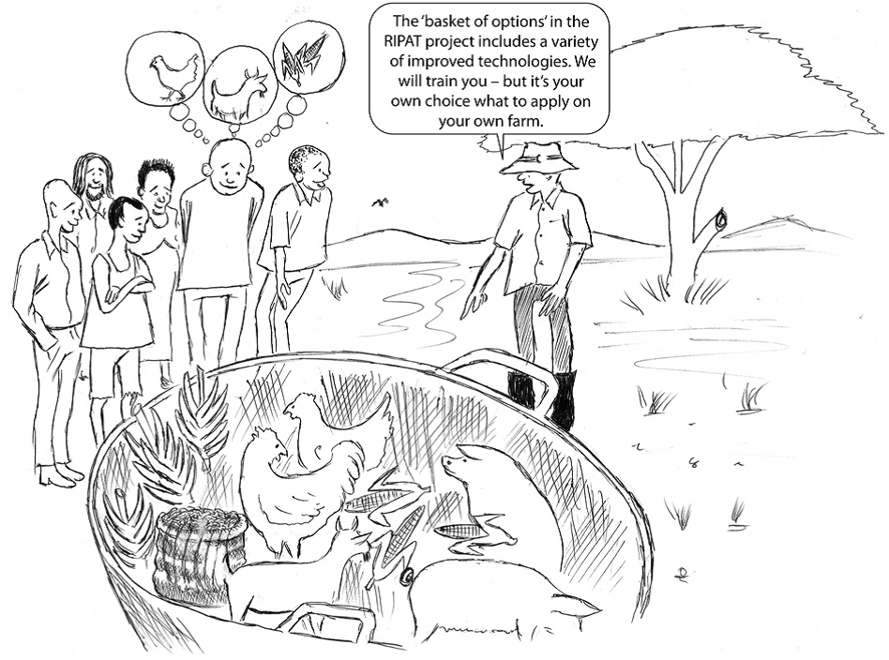
8. Drought Cycle Management (DCM)
Farmers are trained on four stages of droughts and associated measures (mitigation measures) to be taken to manage the drought not to result into hazards; the stages include normal, alarming, danger and recovery (IIRR – Drought cycle management …..). Environmental conservation and drought management are considered during situation analysis and formation of basket of options for a certain locality (farming system / agro-ecological zone) and these becomes part and parcel of the normal agronomical practices and animal management i.e. rainwater harvesting (runoffs utilization), preparation of infiltration pits, contour cultivation, improvement of soil water retention capacity through heavy manuring, irrigation while ensuring good water use efficiency, planting drought tolerant crops, proper zero grazing, milking goats, improvement of local chicken etc. Crop-livestock integration and diversification are important components of DCM: –
a) Crop-livestock integration
This involves combination of crops and livestock i.e. proper linking of crop and livestock production so that they can complement each other and supplement the household livelihood. Emphasis is given on raising improved animal breeds under zero grazing to maximize re-cycling of the resources (animal use crop byproducts and produce manure which is used by crops), environmental conservation, maximize production per unit area (enhance income and food and nutrition security), risk distribution and time management. A few improved animals are introduced to the farmers who then pass on the offspring to one another in a solidarity chain.
b) Crop diversification
Crop diversification through increasing the scope of the crops that are normally grown within the project area aims at profit maximization through exploring new markets and risk diversification against crop failure due to drought (introduction of drought tolerant crops), diseases, etc. New crops and managements to be introduced in a certain area are determined during situation analysis and incorporated in the basket of options.
N.B: DCM and environmental conservation are mainstreamed in normal agronomical practices and animal production of different crops and livestock
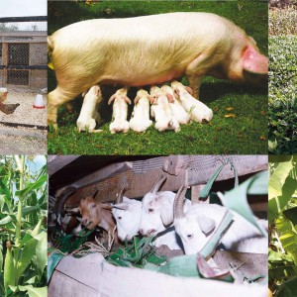
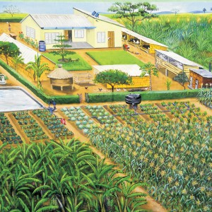
9. Advocacy and Good Governance
Civic education is conducted to enlighten community on their rights and learn to demand and defend them. This is done through leadership training and on other hand democratic leadership is advocated for at all levels. Leaders are taught on how to plan and execute their daily activities more successful. The group members are trained to realize that they are also leaders (development ambassadors) and need to be proactive. Transparency and accountability are given due attention in ensuring the expected objectives are met. The governance practice starts within the groups and is expected to flow to the sub-village and village levels.
Challenges/problems to community economic development and the related issues are correlated with appropriate policy action or community empowerment required to be in place. Issues related with marketing (use of fake measurements, middlemen, unnecessary tax, etc), issues of free range grazing to safeguard perennial crops (bylaws establishment and/or enforcement, community empowerment …), increase national annual budget for agriculture to reach 10%, Government to adoption RIPAT approach as one of the extension systems in Tanzania.
10. Value chain analysis
In order to establish a driving force for the production, agricultural marketing channels are established inclusive with the value chain links. The farmers are trained on different links in the whole system from production to the end users whereby different links and their interactions are analyzed i.e. agro-dealers (suppliers of seeds, fertilizers, agro-chemicals, … ), Extension services (government field officers, NGOs, Super farmers …), transporters, Tanzania Bureau of Standards – TBS, processors, buyers/middle men, marketing, customers (utilization) etc. marketing of the produce and this goes hand in hand with post harvest handling including food storage, processing and utilization. Values chains of improved banana varieties and Orange fleshed sweet potatoes (OFSP) have been developed at the project level together with facilitating group farmers and individuals to develop crop based business plans. Important tips on marketing agricultural products are given.
11. Rural micro-financing (Village Savings and Loan Association – VSLA)
RECODA has the required technical knowledge for facilitating VSLA. From the realization that most farmers in the rural areas do not access saving and credit services from the conventional financial institutions, RIPAT projects train farmers on mobilizing of the local resources (cash) for the same purpose. This is because most farmers are resource poor and even the small revenue that they earn needs to be boosted in order to meet the farmer needs. The farmers are trained on Village Savings and Loan Associations which ensure that from the earnings of the interventions trained under RIPAT project, the farmers save some of the cash and later access loans. The VSLA groups are instrumental in strengthening the production groups especially in ensuring group cohesion – good attendance and punctuality.
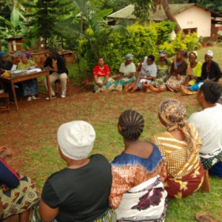
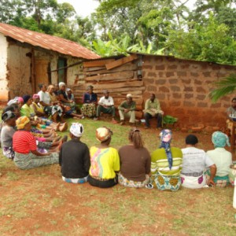
12 .Monitoring and Quality Control in the projects
In the RIPAT projects, there is continuous study and monitoring of the project activities. From the results of the monitoring, Action Learning and Reflection (ALR) are employed to ensure that the project produces the desired results. The projects set milestones which are monitored and are used to establish whether the required standards are achieved. The quality control is undertaken at specific times within the project implementation period and the results are used to improve the project in all dimensions. Department of Quality Control and certification are well equipped as a third eye – using smart phone mobile based programs which collect the data and upload it into a central system which can be accessed through the computer. The program enables easy collection of data and comparison of the same between groups in the project.
- Field days and up-scaling of the innovation
Field days are held so that implemented innovations are exposed to more farmers / stakeholders. The field days include those that are held at the village level and those held at the project level. The major purpose is to advocate for more farmers to adopt the interventions that have been implemented by the group members. Explanations of the intervention performance are given by participating farmers and farmer representatives will do assessment of the technology. Exchange visits through group to group and farmer to farmer’s field visits are facilitated
THE COST EFFICIENT TWO- PHASE RIPAT MODEL
The method project will follows RIPAT manual to ensure that all earmarked commodities in the basket of option are introduced with the payback concept so as to discourage dependency syndrome while encouraging sharing of introduced interventions. For a in 20 villages for three years RIPAT start and one year RIPAT spreading (3+1 years) the following are expected : –
Primary beneficiaries / target groups: Year 1-3(RIPAT ‘start’): 10 villages and 20 groups of 35 HH = 700 households
Secondary beneficiaries: – During RIPAT ‘start’ each group member will train at least 3 others in the community: (3 x 700) = 2,100 households; In year 3 or 4 during RIPAT ‘spreading’ 10 villages; 20 groups of 35HH = 700 households will be targeted; and under the mechanisms of help to self help will lead to (700×3) + 700 = 2,800 households.
Implementing project to 10 villages for 3 + 1 years under provided generic basket of options and with separate transport cost; each village in the RIPAT ’start project’ will need at least 10,000,000Tsh – 20,000,000 (5,000$ – 10,000,$) per year; hence for three years about 30,000,000 – 60,000,000 (15,000 – 30,000$) will be needed; i.e. 300,000,000 – 600,000,000(150,000 – 300,000$)for three – four years
For RIPAT ’spreading’ to another 10 villages, 1/3 (one third) of the total cost used in RIPAT start will be required hoping most of the task will be done by the community-based experts i.e. Super farmers and Extension officers. Hence the cost for RIPAT ’spreading’ will be 100,000,000 – 200,000,000Tsh or 50,000 – 100,000$
As the project target 5,600 HH; and if each HH have at least 5 members; then 28,000 individuals will benefit from the project within the 4 years period by using 400,000,000 – 800,000,000Tsh (200,000 – 400,000$). In this case each HH will spend only 72,000 – 144,000Tsh (36 – 72$); if divide to 5 members of the HH; each individual will have to spend about 15,000 30,000Tsh (7 – 15$).
N.B: – Transportation cost is not included but if the project car is used (no mileage charges) the transport charges can be very be very low.
– For exploiting the economies of scale and for good project performance, the number of villages/parishes should range between 5 – 10; i.e. less than 5 may lead to budget increase (high cost project) and >10 may dilute the job i.e. spread too thinly.
– The project payback/economic returns can be calculated based on the proposed basket of options and it will be amazing development can be such a simple thing!

WHAT GREAT PEOPLE SAY ABOUT RIPAT
In Arumeru and Karatu districts I witnessed farmers using the RIPAT approach to substantially increase their productivity and incomes in banana production; to improve their levels of innovation, participation, and ownership of their projects; and hence to transform their lives. The approach also addressed the dependency syndrome of the farmers and reinforced their application of the most cherished principle of self-reliance in their own development.’ The Hon. IsidoreLekaShirima, the former Regional Commissioner of Arusha, Tanzania)
The RIPAT Manual is a must read for extension services providers as it provides a detailed step-by-step guide to dissemination of agricultural technologies to small scale farmers and how to scale-out beyond the groups trained. It clearly indicates the roles of various players and giving out the DOs and DON’Ts. The group approach creates cohesion and builds confidence amongst poor resource farmers and brings in the “YES WE CAN” spirit that reduces dependence on free hands outs. The introduction of the “basket of technology options” provides farmers with a wide choice of technologies enabling each farmer to select one or more intervention to adopt according to his /her like and availability of own resources. This enables all farmers in the group to participate and brings about sustainability.’ By Dr. Mary Shetto, MAFSC – SAGCOT coordinator
Under Resources:
- Publications related with RIPAT
- Farmers’ Choice: Evaluating an approach to agricultural technology adoption in Tanzania. Edited by Helene Bie Lilleor, and Ulrik Lund Sorensen. Rockwool Foundation Research Unit.
- The RIPAT Manual: Rural Initiatives for Participatory Agricultural Transformation by Vesterager, J.M., Ringo, D., Maguzu, C. W., Ng’ang’a, J.N. (2013) The RIPAT manual – Rural Initiatives for Participatory Agricultural Transformation, Copenhagen: The Rockwool Foundation, Denmark.
- Can Agricultural Interventions Improve Child Health? Evidence from Tanzania by Anna Folke Larsen &Hellen Bie Lilleor
- Agricultural technology adoption, food security, poverty and child health; Assessments of an agricultural intervention in Tanzania by Anna Folke Larsen – PhD Series No. 174 – 2015
- Poster on Rural Agricultural Development Innovation for Food and Nutrition Security – Findings From a Study in Tanzaniaby Jens M. Vesterager, Helene B. Lilleør; The Rockwool Foundation, Denmark; Dominick Ringo; RECODA, Tanzania
- How introduction of dairy goat production affects smallholder farmers – A case study Of an agricultural development project in Karatu district, Tanzania by Majbrit Terkelsen Aarhus University Master’s Degree Programme: Agrobiology

- Other Publications
The organization was consulted by FAO in 2007 to undertake a case study on Conservation agriculture in Karatu and Arumeru district. The results were documented in a book called Conservation Agriculture as practised in Tanzania: three case studies – www.fao.org/ag/ca/doc/Tanzania_casestudy.pd
Through implementing her projects, RECODA participated in the documentation of the Conservation Agriculture manual for farmers and extension workers in Africa, published 2005 by the international Institute of Rural Reconstruction and the African Conservation Tillage Network
- References
Banerjee, A. and Duflo, E. (2011) Poor Economics: A Radical Rethinking of the Way to Fight Global Poverty, Public Affairs, New York.
Lilleør, H.B. and Lund-Sørensen, U. (eds).Farmers’ Choice – Evaluating an approach to agricultural technology adoption in Tanzania Practical Action Publishing, 2013. 168p.
Vesterager, J.M., Ringo, D., Maguzu, C. W., Ng’ang’a, J.N. (2013) The RIPAT manual – Rural Initiatives for Participatory Agricultural Transformation, Copenhagen: The Rockwool Foundation, Denmark. 142p.
The RIPAT Manual: Rural Initiatives for Participatory Agricultural Transformation
By Jens M. Vesterager, D Ringo, C.W Maguzu and J.N Ng’ang’a
To Download click the link: http://www.ripat.or.tz/downloads/

